**CHAPTER 4**

**RESULT AND DISCUSSION**

1. RESULTS

**Lighting and Illumination Issues**

Illumination problem is one of the existing algorithm’s reasons in providing inaccurate results. The algorithm has no way of being aware when an image input has a certain illumination issue and tend to continue on with the face recognition procedure even without resolving the issue which can ultimately cause inability to recognize an input image, thus making less accurate results in recognition.

**Image Adjustments Before Recognition**

Input images’ image data that has illumination problems (too bright or too dark) are optimized and adjusted accordingly. The proposed algorithm has the capacity to identify the image’s illumination status whether it’s normal, too bright, or too dark. The desired illumination is determined by the training faces’ image data mean and it will be the basis of the input image illumination status. This prevents the algorithm to proceed to the facial recognition procedure without resolving illumination issue, thus increasing the recognition accuracy.

6 Actual Image Adjustments Results:

1. Original image dark

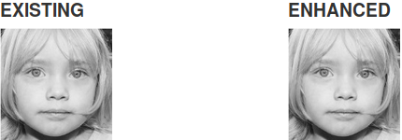

2. Original image is normal



3.  
Original image is dark

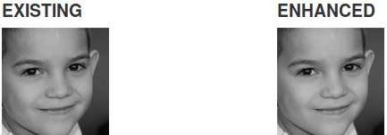

4.   
Original image is normal

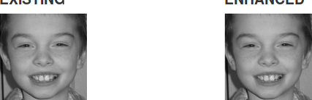  
  
5. Original image is normal

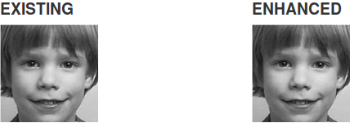  
  
6. Original image is normal

***Figure 4.1****: Result of applying illumination adjustment on Problem 1.*

**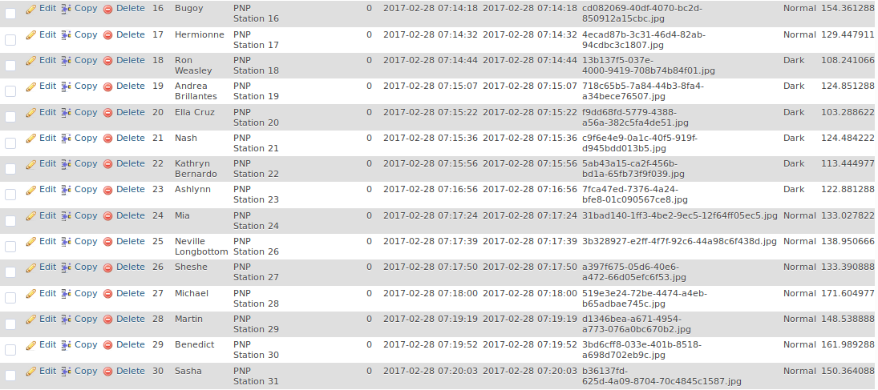****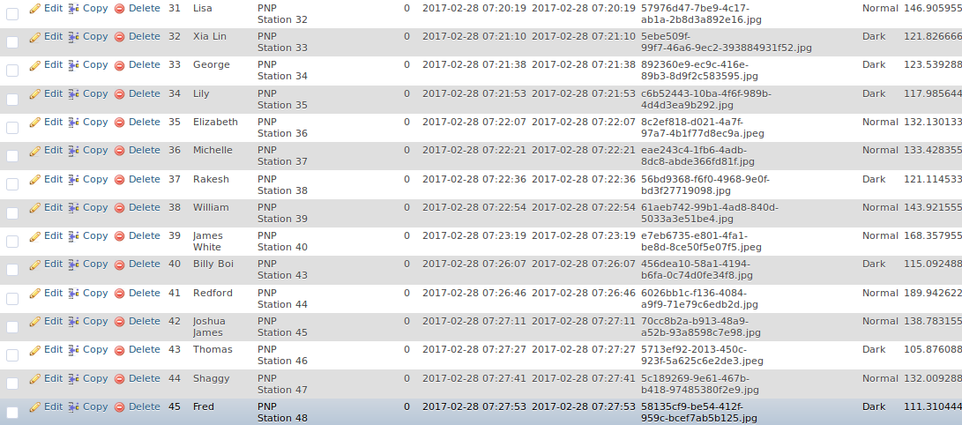**DATABASE of 50 Images:

***Figure 4.2****: DATABASE of 50 Images existing in the system and their lighting condition.*

**No Common Threshold Applied**

The algorithm doesn’t know when an input doesn’t exist in the system. The algorithm still recommends the best match regardless of how small the similarity is between the input image and the best match. This results in mismatch in recognition which is a big issue.

**Threshold Applied**

Having applied a common threshold before proceeding to the recommendation, the system is now able to determine whether the input image exists in the system. This will result in an unknown person rather than an unreliable result. An input which is non-existent in the system will have a “No Match Found” result in the system rather than an unreliable recommended result.

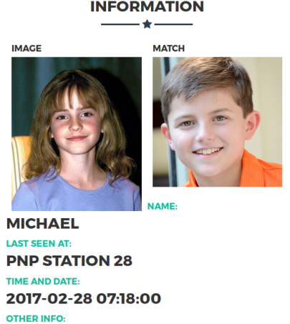 Existing: Proposed:

***Figure 4.1****: Comparison of Existing and Proposed Algorithm on Problem 2.*

**Processing Level Graph using Dimension Reduction**

The PCA’s Dimension Reduction was intended to improve the processing level efficiency of the computation of the covariance matrix. However, its efficiency can only be maintained under a specific condition. Such condition is where ***M*** is lower than ***N2.*** However, ***M*** can continuously increase in number while ***N*** remains constant. On that note, the Dimension Reduction continuously increases the processing level, the exact opposite of its intended purpose, as the value of ***M*** increases as shown in **Graph 4.1**.

***M***

***Graph 4.1****: Size growth of Covariance Matrix as* ***M*** *increases using* ***ATA*** *formula.*

**Processing Level Graph using Proposed Solution**

The proposed algorithm reverts back the computation of the covariance matrix to its original form (***AAt***) once the Dimension Reduction can no longer serve its purpose which is when ***M*** reaches a value higher than ***N2.*** Following this procedure, the processing level can be maintained as low as possible and will not increase uncontrollably, thus preventing increasingly large computations to take place as shown in **Graph 4.2**. In this case ***N = 50, N2 = 2500***.

This is where the computation for Covariance Matrix switches to ***AAT***

2500 2500

***M***

***N2***

***Graph 4.2****: Size growth of Covariance Matrix as using proposed formula.*

Computation runtime of Covariance Matrix,  
given ***M*** = 2600, ***N*** = 50  
  
Existing:

Proposed:

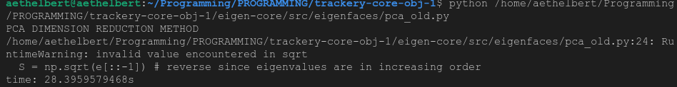



***Figure 4.3****: Comparison of Computation Runtime between Existing and Proposed Algorithm on Problem 3.*

1. DISCUSSIONS

**Image Illumination Adjustment**

We gave the algorithm a first-hand solution to the illumination issue before it proceeds for facial recognition reduces Eigenface’s sensitivity to illumination thus improving the accuracy of finding a match even when introduced to an illumination problem. It is an effective way of resolving the issue at hand by setting an average brightness threshold before an image is put into the training set or before recognition.

**Dimension Reduction**

The Dimension Reduction can certainly reduce the efficiency of the algorithm in the long run due to the increasing number of ***M***. However, this does not mean that it will be completely removed from the system. It is actually quite effective and reliable when the system is still in its infancy. The proposed algorithm offers to revert the formula for the covariance matrix back to its original form once the Dimension Reduction reaches its peak and unable to provide its intended purpose anymore.